**The Tragedy of Flight: A Comprehensive Crash** **Analysis**

**Project Report**

**1. OVERVIEW:**

**1.1 Indroduction:**

An Airplane Crash Analysis Is a Detailed Invertigation Into The Causes Of An Airoplane Crash Analysis is To Identity Any Factors That Contributed To The Accident With The Uldemate Goal Of Improving Safty And Procenting Future Accident.

**1.2 Purpose:**

To Create Thrust So As To Be Able To Gain Height,And To Push Through The Air To Overcome The Drag Associaded With Lift All Takes Energy.

Different Objects And Creatares Capable Of Flight Vary In The Efficiancy Of Their Muscles, Motors And How Well This Translates Into Forward Thrust.It Generates Econamical Growth,Creates Jobs And Facilities International Trade & Tourism.

1. **PROBLEM DEFINITION & DESIGN THINKING:**

**2.1 EMPATHY MAP**

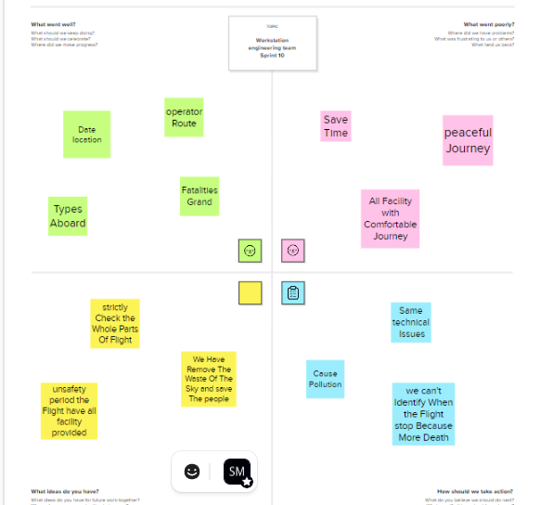

**2.2 IDEATION & BRAINSTORMING**

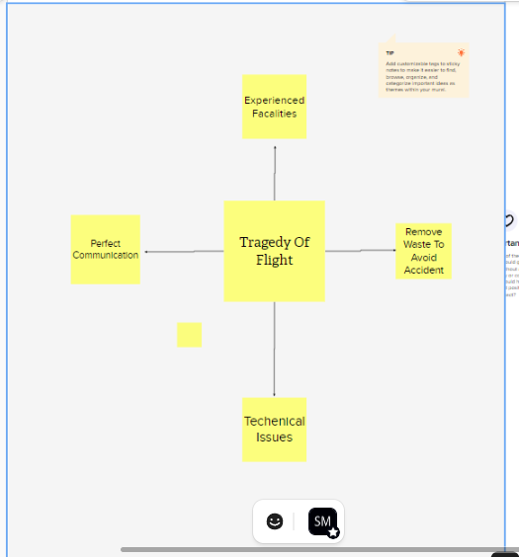

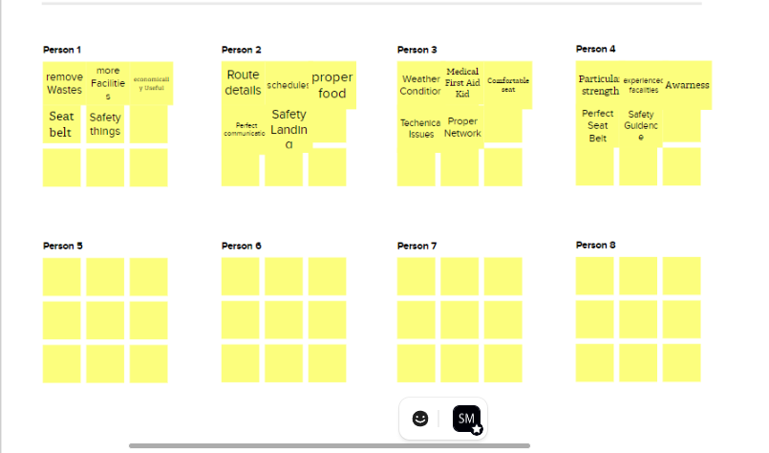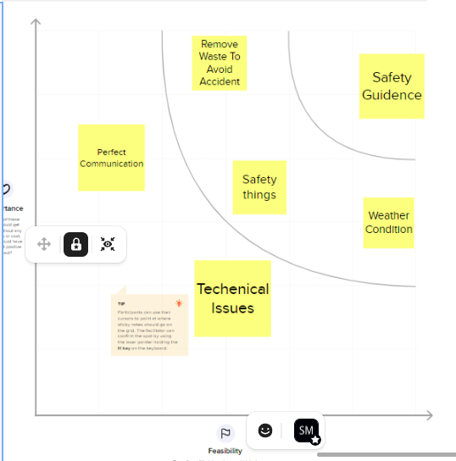

1. **RESULT:**

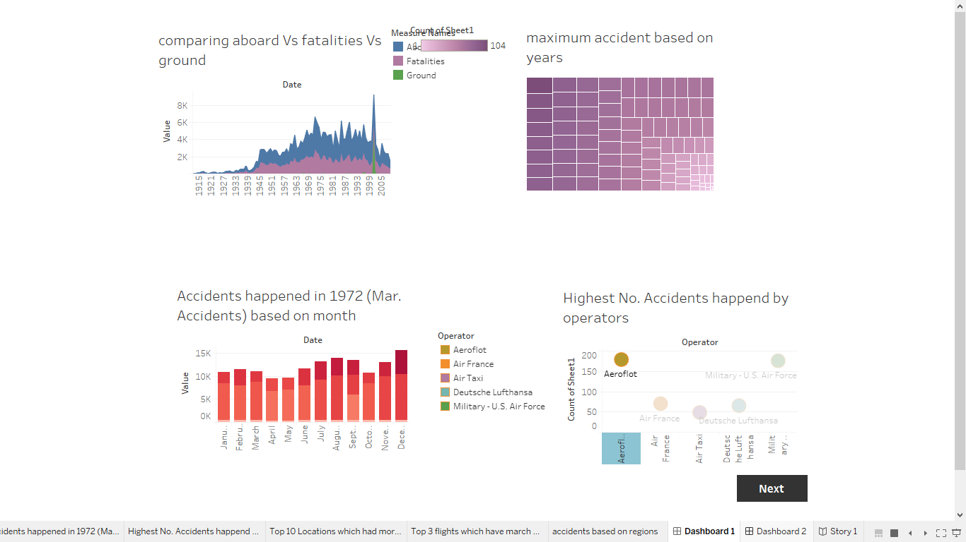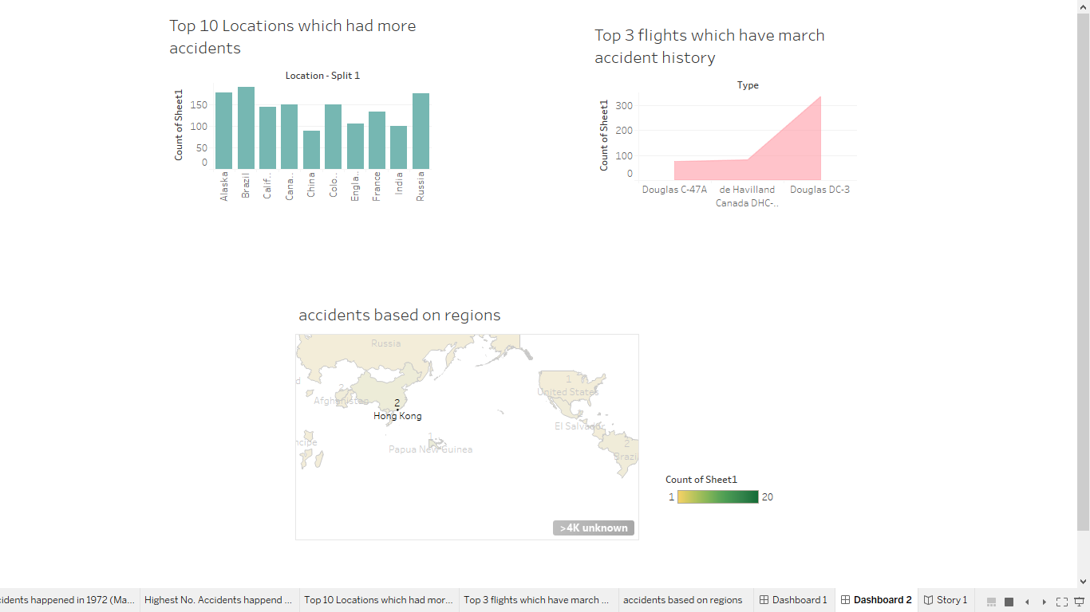

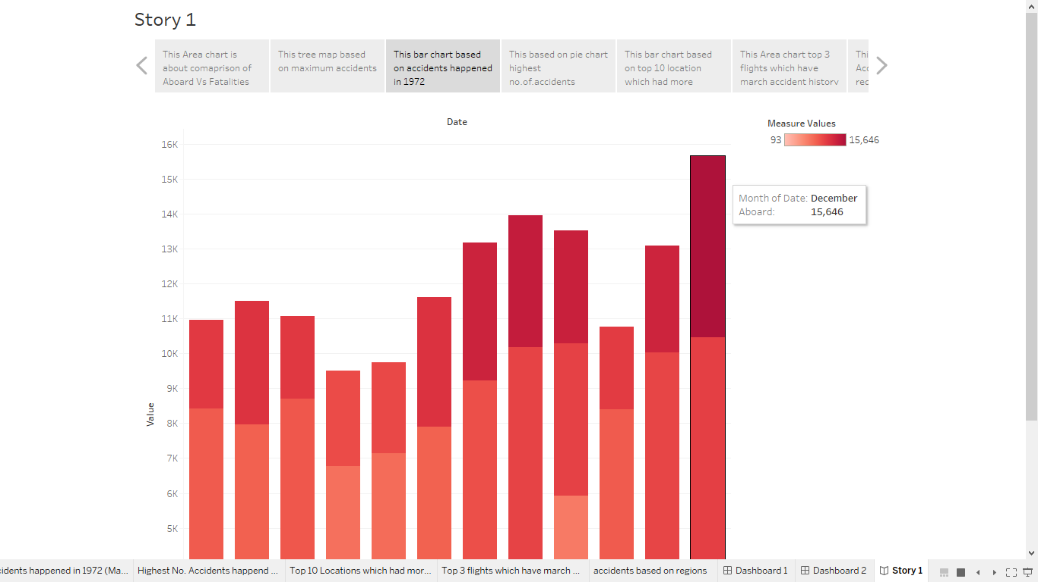**4. ADAVANTAGES AND DISADVANTAGES**

ADVANDAGES OF FLIGHT:

* + - * It's The Fastest Way To Travel Long Distance. Air Travel Is The Fastest Way To Travel Long Distance.
      * It's The Most Efficient Way To Travel distance. Air Travel Is Also The Most Effficient Way to Travel Long Distance.
      * Planes Can Carry a Lot Of Weight.

" YOU CAN FLY EVERYWHERE IT'S SAFE"

DISADVANDAGES OF FLIGHT:

* + - * It's Is More Expensive Than Other Types Of Transport Because Fuel Is Expensive.
      * It's Has Capacity Limits.
      * It's More Polluting Than Other More Suatainable Mean Of Transport Such As Electric Vehicles.

**5. APPLICATION:**

The Board Spectrum Of Uses For Airplane Includes Recreation, Transportation Of Goods And People, Military And Research.

**6. CONCLUSION:**

Flight Planning Is Important For Making The Flight Safe And Efficient, Where The Most Priority For Any Flight Is To Achieve Safety ,Then As Any Commercial Organization, They Care About Making Efficient Flight Without Compromising With Safety.

**7. FUTURE SCOPE OF FLIGHT:**

Emerging Technologies Are Reshaping With Robotics,Artificial Intelligence, The Internet Of Things, Unmanned Aircraft Systems And The Push For Hybrid And Electric Airplanes-Just To Name a Few. Alternative Fuels Can Significatly Change The Current Scanerio Of Aviation In Support Of The Environment Protection.

**8. APPENDIX:**

**A. Source Code:** Saranya Team Final Project.html